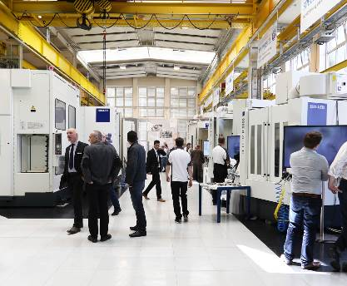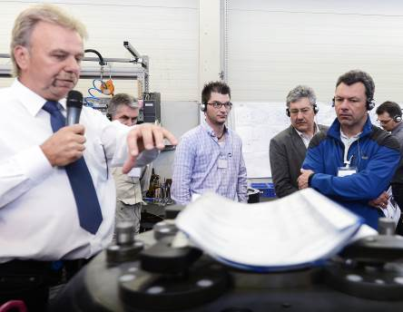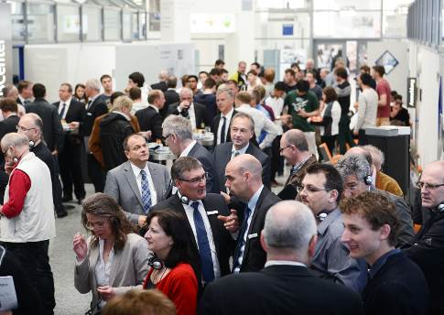

May 2014

HELLER WerkTage 2014:
Meeting Place for Experts

Press relations
Gebr. Heller Maschinenfabrik GmbH

Marketing
Marcus Kurringer
Gebrüder-Heller-Straße 15
72622 Nürtingen
Germany
Phone: +49 7022 77-5683
Fax: +49 7022 77-165683
marcus.kurringer@heller.biz

5-axis competence and precision. Process dependability included.
Current discussions about 5-axis machining centres are ongoing. Whilst some sceptics claim that more challenging programming or higher demands on the machine and the control speak against the technology, insiders emphasise the benefits of faster machining resulting in savings potentials plus higher precision and reduced tool wear due to shorter milling paths. That is also why HELLER placed the focus on this particular technology during WerkTage 2014, being already the 7th edition of this event. With seven machining centres live in action, guided plant tours and moderated panel discussions, the event was again fully geared towards the tasks of the users.
Already ahead of the event, organisers were aware of the expected number of visitors and an international response to WerkTage 2014. However, none of them had anticipated that they would be welcoming more than 800 guests from 20 different countries. With a share of more than 60%, the majority of visitors still came from Germany, followed by guests from Switzerland, Portugal, Spain and the US. Just as diverse as the nationalities of visitors to Nürtingen were the branches of industries interested in economically viable manufacturing solutions, including representatives from the automotive industry and its suppliers, machine builders, mould and die manufactures through to aerospace companies.
The 7th edition of HELLER WerkTage provided visitors with an opportunity to gain an understanding of tomorrow's trends. Aspects presented included solutions offering precision and 5-axis competence and a comprehensive approach to the process chain. HELLER demonstrated its full spectrum of productivity with seven machining centres on display, machining a diverse range of components and meeting a wide variety of requirements. An out-facing head solution and trochoidal milling, universal application using oversized tools and boring in all its facets were presented on three 4-axis machining centres from the H series. Three 5-axis machining centres from the F series were the focal points in terms of 5-axis machining. Model FP 4000 demonstrated high precision with in-process gauging and 5-axis machining from 6 sides, whilst model FT 4000 showcased strategic 5-axis simultaneous machining. Additionally, HELLER cycles and combined mill/turning operations were demonstrated on 5-axis machining centre model CP 8000. Live machining demonstrations were complemented by a total of three new developments and numerous product enhancements, including the expansion of the process chain in crankcase manufacturing with HELLER CBC (CylinderBoreCoating).
This year for the first time, practical machine demonstrations were accompanied by moderated panel discussions. They also provided an opportunity to focus on a number of decisive questions: implementation in practical application or the questions of why, when or which solutions are chosen and how these strategies are transferable to other fields. Volker Schmitt, Head of Industrial Engineering Manufacturing at Linde Hydraulics GmbH in Aschaffenburg, for instance, illustrated cost-effective manufacturing of special cylinder blocks for axial piston pumps through use of a 5-axis machining centre. Up to now, these components have been manufactured using 4-axis machines with an additional attachment axis on the pallet. One specific type of cylinder block required machining in two setups, resulting in a very laborious process accompanied by a loss in quality and repeatability. To enable machining of the inclined bores in a single setup, a 5-axis solution was needed. For Linde Hydraulics, the decisive advantage was that the FP series of machines and the fork-head unit allowed machining at negative angles below the centre axis. The Aschaffenburg-based company required machining at a negative angle of 21°.
Formula for success for reliable operation
For Walter Kreidler, Managing Director of Kreidler GmbH & Co. KG in Horb, chip removal rate, dynamics, precision and reliability of the HELLER machines are the measure of all things. The requirements in terms of precision and availability in the machining of its workpiece spectrum, including parts for leading German transmission manufacturers, are usually extremely high and complex. Walter Kreidler comments: “Being confronted with challenging operations almost every day, these requirements are nothing new to us. Although the term 'challenging' is relative. It depends on what you are referring to. The die casting industry is subject to high standards and demands. Knowing this, you adapt to these requirements and adopt a conscientious approach. Walter Kreidler has his own recipe for achieving “precision and reliability for safe production processes” which has proven successful over many years: “I have known the machines supplied by HELLER from the very first day and we know what we are doing with them. HELLER may come at a higher price tag than other manufacturers, however, the longevity of the machines compensates for that. For reliable operation the machines simply have to keep running – around the clock. In my opinion, switching the machines on and off, powering them up and down, resulting in temperature fluctuations that have a negative effect on the lifetime of a machine. When operating the machines at constant temperatures, there are virtually no problems at all.” The company based in Horb achieves the required precision with complete machining in a single setup, without making a difference between roughing and finishing operations. According to Walter Kreidler this has no negative effects on the machines whatsoever: “We have been operating machines for 15 years still using the same guideways. We even purchased an 11-year-old machine model MC 16 from HELLER. Right from its installation the machine has been providing the same high precision as a new one. We never had to replace a spindle or guide rails. Workpieces are machined at high precision. We are using the machine for machining of current crankcase types.”
Availability at 95 percent even without automation
The above approach may sound a little strange to Karl Semmelmann, Head of Engineering and Development at MDS Abele GmbH & Co. KG. The company based in Mühlacker is required to achieve a process capability of Cm/Cmk 1.67. As a whole, the component in question required extremely high manufacturing precision in alternate machining. Due to the required Cm/Cmk 1.67 capability, tolerances were reduced from 0.05mm to 0.035mm. With daily batch sizes of 50, 220 and 500 pieces, precision and process capability have to be provided over a long period at high process dependability. That is why the company from Mühlacker opted for two 4-axis machining centres model H 4000 from HELLER. The machines commissionined in 2013 were immediately used for production. Although the company had expected them to require a certain start-up phase, they already reached 95 to 96 percent availability without the use of automation.
According to Karl Semmelmann, the stability of the machines contributes significantly to the high availability by safeguarding a high level of repeatability, whilst eliminating fluctuations in terms of stiffness and thermal growth. Following a short warm-up phase the machines are ready for machining from the thermal and mechanical point of view. The focus at MDS Abele is not on chip removal rate but on high speeds, high feed rates and precision. These attributes are not necessarily associated with horizontal machining centres. For Karl Semmelmann these things are relative: “In case of manufacturers providing other concepts the question is whether rapid traverse rates can be achieved across the overall traverse path at all. Model H 4000 has a traverse path of 800mm. However, if you accelerate across this distance, you also need to be able to decelerate. Operating costs are an important factor to be considered in this context. Today's power consumption of linear drives almost requires a separate power generator for every machine.”
That exactly was the decisive factor for the company from Mühlacker. According to its calculations, the cost of power has increased by 60 percent in the last 5 years. Independent of political decisions, the company assumes that the increase is likely to continue in the coming years.
Insights, transparency, perspectives
This year, HELLER also welcomed renowned process chain suppliers to the event. In particular automation manufacturers KUKA, SCHULER, GÜDEL, LIEBHERR, RILE and FASTEMS provided information about solutions for stand-alone machines and linked machining centres. Additionally, the perfect symbiosis of a virtual and transparent machine provided in-depth insights. HELLER showcased a transparent machine model FP 4000, illustrating the quality of the machine structure, whilst virtual machining revealed the possibilities for optimising the process chain from the idea to the finished part. The programme was rounded off with a presentation of the complete portfolio of HELLER Services and our partner WENZLER, attractive financing solutions and a comprehensive exhibition of workpieces and finished products of numerous HELLER customers.
As during previous editions, HELLER WerkTage 2014 also provided an opportunity to visit Plants 1 and 2. In addition to insights into manufacturing, sub-assembly installation, final assembly and vocational training, visitors had a chance to learn more about the assembly of crankshaft machines, large-part manufacturing and retrofitting “Made by HELLER”.
Already in 2013, organisers at HELLER were confident that the 2014 event would again be a meeting place for experts in step with actual practice. The exchange of experiences and the technologies in focus contributed to fulfilling these expectations. Another important factor in the event's success was the participation of partner companies and market leaders from the automation industry, suppliers of measurement and inspection equipment and clamping fixture providers, providing the relevant technology competence. They were able to present a wide range of possibilities for realising manufacturing solutions for a broad spectrum of components and workpieces.

Short profile HELLER Group
Founded in: 1894 in Nürtingen
Workforce 2013: 2,450
Turnover 2013: EUR 533m
Chairman of the Board: Berndt Heller
Managing Directors: Manfred Maier (COO of the HELLER Group)
Christian Pfleiderer (HELLER Services GmbH)
Klaus Winkler (CEO of the HELLER Gruppe)
Fields of business: Horizontal machining centres, 5-axis machining centres, mill/turning centres, flexible manufacturing systems, crankshaft and camshaft machines, CBC systems, services
Production locations: Germany (Nürtingen) United Kingdom (Redditch) USA (Troy/Michigan) Brazil (Sorocaba)
China (Changzhou)
Sales/Service locations: EUROPE:
Deutschland (Hattingen, Salem, Goslar, Saarbrücken, Kirchheim,
Nuremberg)
Italy (Verona) France (Paris) Spain (Barcelona, Santander)
Sweden (Värnamo)
Switzerland (Niederbüren)
Slovakia (Vráble)
Russia (Yekaterinburg)
NORTH/SOUTH AMERICA
Mexico (Querétaro) Brazil (Belo Horizonte, Gravataí, Joinville)
ASIA
China (Beijing, Changchun, Shanghai, Chongqing, Nanning)
India (Pune)
Thailand (Bangkok)
Singapore

